# **Name: Abdurrahman Qureshi**

# **Roll No: 210451**

Practical No: 12

1. Creating a user-defined module to ask for the college name and display it
2. Write a Python program to create a user defined module that will ask your college name and will display the name of the college.
3. Write a Python program that will calculate area and circumference of circle using inbuilt Math Module
4. Write a Python program that will display Calendar of given month using Calendar Module

__init__.py:

from . import chars

Chars.py:

import math  
import calendar  
  
def display_calendar(year, month):  
 print(calendar.month(year, month))  
def get_college_name():  
 return input("Enter your college name: ")  
  
def display_college_name(college_name):  
 print("College Name:", college_name)  
  
def calculate_area(radius):  
 return math.pi * radius ** 2  
  
def calculate_circumference(radius):  
 return 2 * math.pi * radius  
  
def student_info():  
 name = input("Enter your name: ")  
 age = input("Enter your age: ")  
 print(f"Your name is {name} and your age is {age}")

Main.py:

import my_package  
  
my_package.chars.display_college_name(my_package.chars.get_college_name())  
print(my_package.chars.calculate_area(7))  
print(my_package.chars.display_calendar(2024,1))  
my_package.chars.student_info()

OUTPUT:

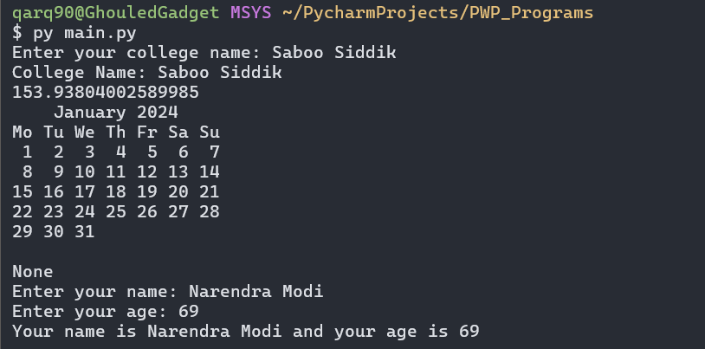

EXTRA QUESTIONS

**2) Create a user defined module with add, sub, mul and division method. Print the result while importing the module**

Chars.py:

def add(x, y):  
 return x + y  
  
def sub(x, y):  
 return x - y  
  
def mul(x, y):  
 return x * y  
  
def division(x, y):  
 if y == 0:  
 return "Cannot divide by zero"  
 return x / y

Main.py:

import my_package.chars as CHARS  
  
result_add = CHARS.add(5, 3)  
result_sub = CHARS.sub(5, 3)  
result_mul = CHARS.mul(5, 3)  
result_div = CHARS.division(5, 3)  
  
print("Addition result:", result_add)  
print("Subtraction result:", result_sub)  
print("Multiplication result:", result_mul)  
print("Division result:", result_div)

OUTPUT:

